Web Application Security Assessment Report
1. Project Information
Project Name: Institution's Innovation Council (IIC) Web Application
Assessment Type: Web Application Security Assessment
Testing Environment: Local Development Environment
Assessment Date: 01 August 2026
Tester: Sreenivasa Pai

2. Objective
The objective of this assessment is to perform a comprehensive security evaluation of the Institution's Innovation Council web application. The assessment will be conducted in a local development environment to identify security vulnerabilities, validate their impact, and provide remediation recommendations.

3. Scope
The assessment will cover the web application's available functionality, including authentication mechanisms, authorization controls, input validation, session management, API endpoints, business logic, and client-side security.

4. Testing Environment
Component | Details
Operating System | Windows 11
Browser | Brave Browser
Local Server | localhost
Repository Branch | test
Development Environment | Local

5. Environment Setup
Step 1 – Repository Setup
The project repository was successfully cloned to the local development machine.
Step 2 – Synchronization
The latest code changes were pulled from the test branch to ensure the local environment matched the current development version.
Step 3 – Dependency Installation
All required project dependencies were installed successfully.
Step 4 – Local Execution
The application was started successfully in the local development environment.
The application is accessible through:
http://localhost:5173
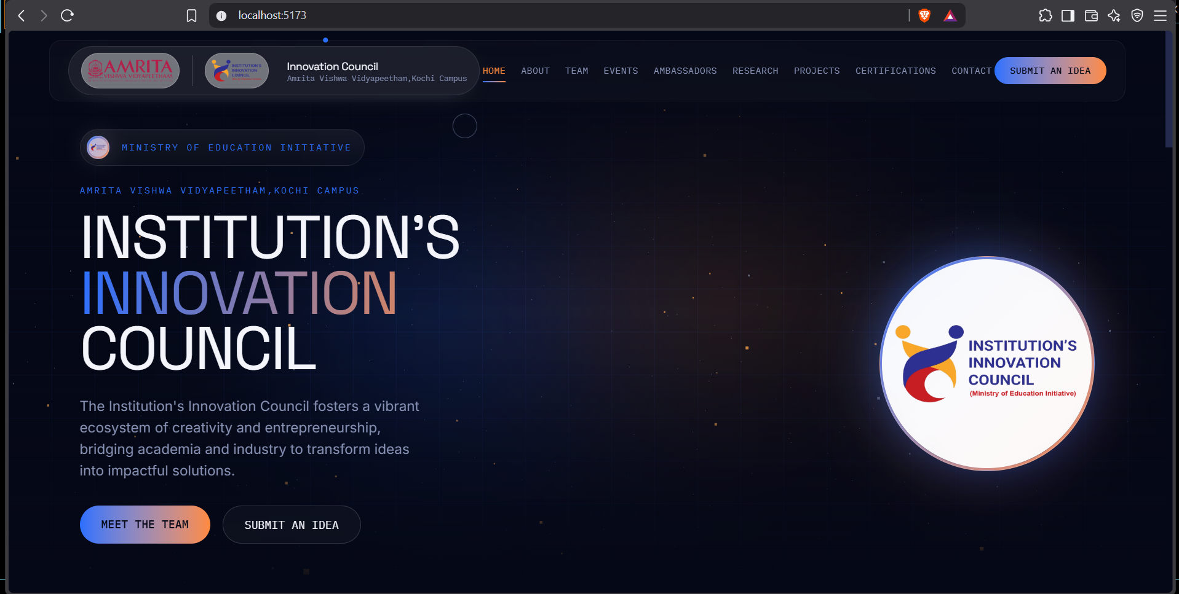
6. Initial Verification
The application launched successfully without startup errors.
The homepage rendered correctly in the browser.
No functional testing has been performed at this stage.

7. Homepage Observation
During the initial inspection, the following user interface components were observed:
Navigation Menu
- Home
- About
- Team
- Events
- Ambassadors
- Research
- Projects
- Certifications
- Contact
- Submit an Idea
Visible Buttons
- Meet the Team
- Submit an Idea
These observations are recorded to establish the application's visible attack surface before security testing begins.

8. Current Status
Activity | Status
Repository cloned | Completed
Latest code pulled | Completed
Dependencies installed | Completed
Application launched locally | Completed
Initial homepage verification | Completed
Security testing | Not Started

9. Network Connectivity Verification
Objective
To verify network communication between the Kali Linux virtual machine (attacker environment) and the Windows host machine (hosting the target web application) before initiating security testing.

Network Configuration
Component | Details
Attacker Machine | Kali Linux 2025.4 (VirtualBox)
Target Machine | Windows 11 Host
Target IP Address | 192.168.1.9
Application Port | 5173
Application URL | http://192.168.1.9:5173

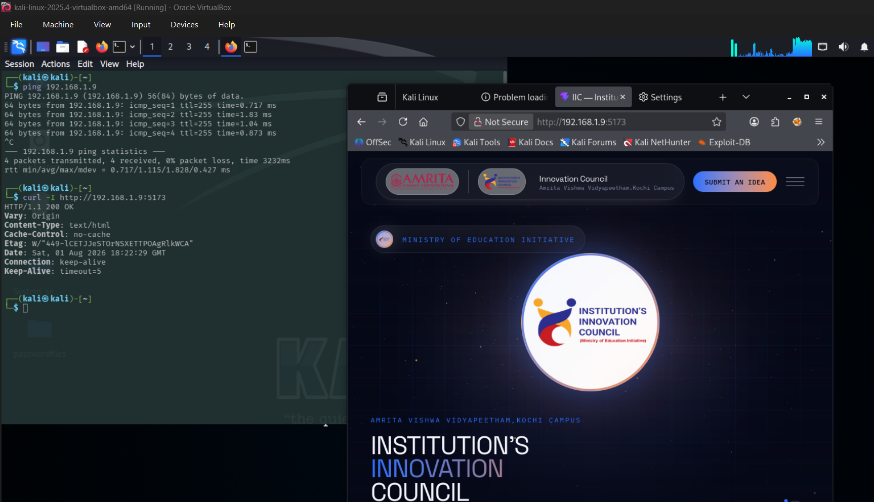
Step 1 – ICMP Connectivity Test
A ping test was performed from the Kali Linux virtual machine to the Windows host to verify basic network connectivity.
Command Executed
ping 192.168.1.9
Result
- Host reachable
- 0% packet loss
- Stable response times
- Network communication successfully established
Observation
Successful ICMP responses confirmed that the Kali virtual machine can communicate with the Windows host over the local network.

Step 2 – HTTP Service Verification
The HTTP service was verified using curl to ensure that the web application was accepting HTTP requests.
Command Executed
curl -I http://192.168.1.9:5173
Response
HTTP/1.1 200 OK
Content-Type: text/html
Observation
The server returned an HTTP 200 OK response, confirming that the web application is running correctly and is accessible from the Kali Linux virtual machine.

Step 3 – Browser Accessibility Test
The application was accessed through the Firefox browser installed on the Kali Linux virtual machine.
URL Accessed
http://192.168.1.9:5173
Result
The homepage loaded successfully without connectivity issues, confirming that the target application is accessible from the attacker environment.

10. Cross-Device Accessibility and Responsive UI Verification
Objective
To verify that the locally hosted web application is accessible from a mobile device connected to the same network and to perform an initial visual inspection of the user interface across different screen sizes.

Test Environment
Component | Details
Host Machine | Windows 11
Target Application | Institution's Innovation Council Web Application
Mobile Device | Android Smartphone (or specify your device model if desired)
Connection | Same Local Area Network (LAN)
Access Method | Web Browser
Application URL | http://192.168.1.9:5173

Procedure
- Ensured the mobile device was connected to the same local network as the Windows host.
- Opened the mobile web browser.
- Accessed the locally hosted application using the host machine's IP address:
http://192.168.1.9:5173
- Observed the application's user interface on the mobile device.

Observations
- The application was successfully accessible from the mobile device.
- The homepage loaded without connectivity issues.
- Navigation and primary interface components were displayed.
- An initial visual inspection was performed to observe the responsive layout on a mobile screen.
- No detailed functionality or security testing was performed during this stage.

Purpose
This verification was conducted to ensure that the application is reachable from external devices within the local network and to establish a baseline for the application's responsive user interface before commencing the security assessment.
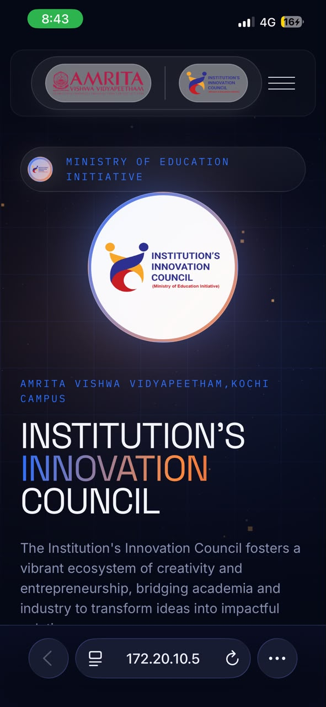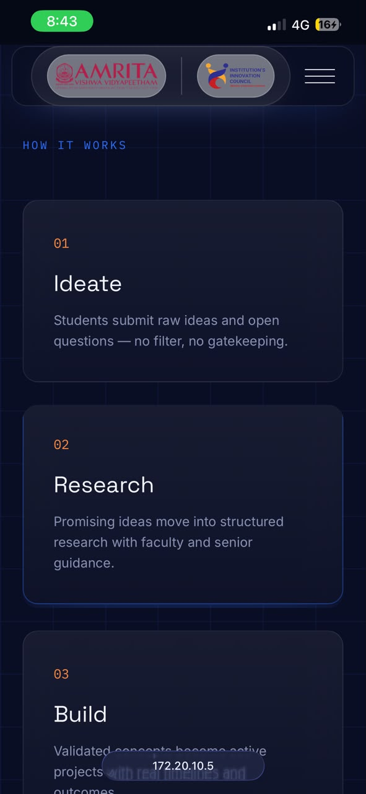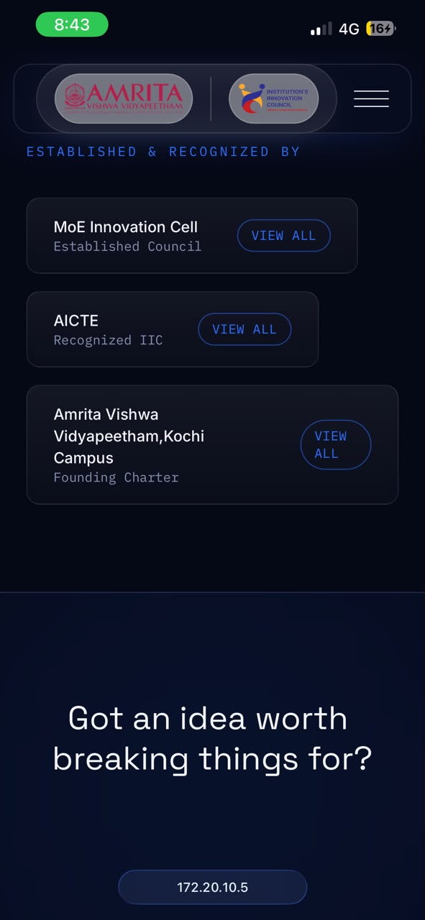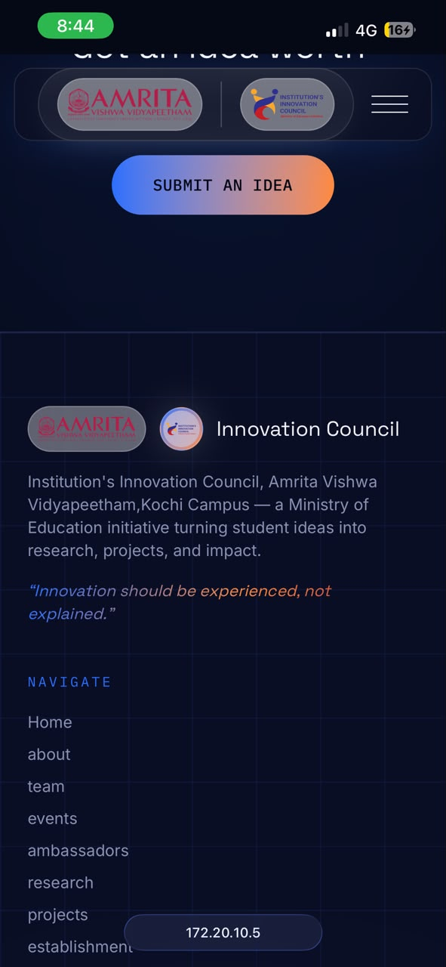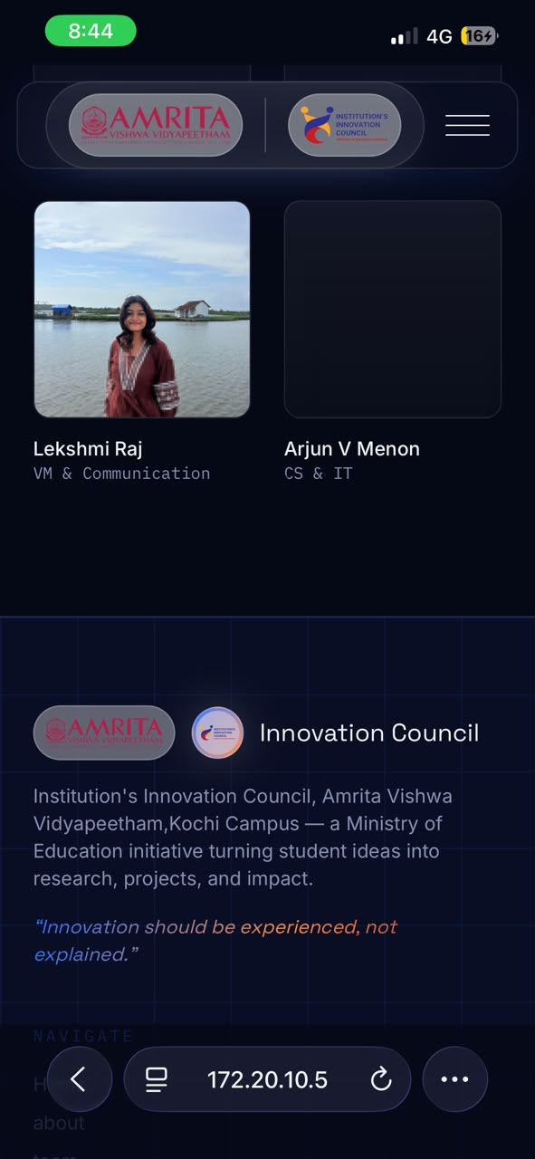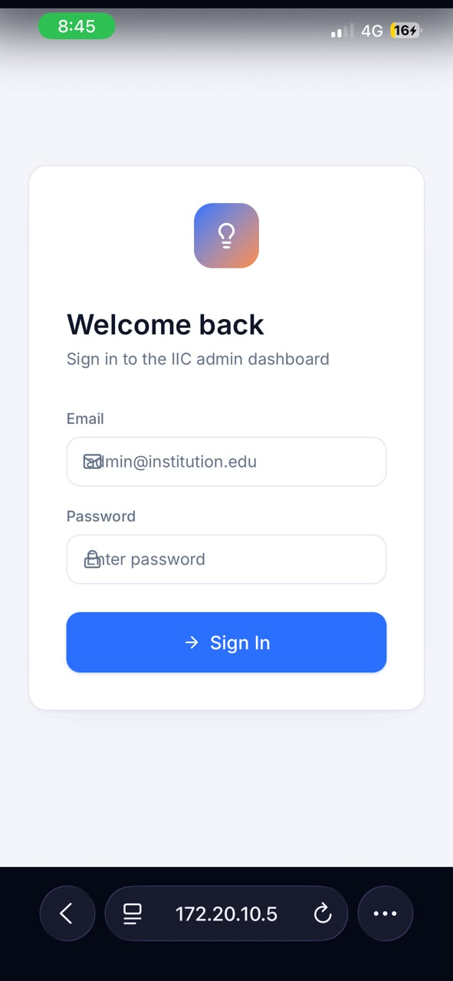

Step 1 – Network and Service Enumeration
Objective
To identify exposed network services and gather basic information about the target web application before conducting application-level security testing.

Tool Used
- Nmap v7.95
Command Executed
nmap -sV --script http-title,http-headers,http-enum -p5173 192.168.1.9
Result
From your screenshot:
- Host is reachable.
- Port 5173/tcp was reported as filtered.
- Service version could not be determined.
- HTTP NSE scripts (http-title, http-headers, http-enum) did not produce output because Nmap could not communicate with the service.
Observation
Although the application was accessible through a web browser, the Nmap scan reported the port as filtered. This may occur in local development environments due to firewall rules, proxy settings, or the behavior of the development server. Further HTTP-based testing will be performed directly through the browser and interception proxy.
‘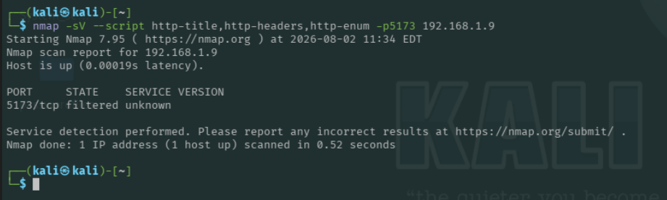

Step 2 – Directory Enumeration
Objective
To enumerate publicly accessible directories and resources exposed by the web application.
Tool Used
- FFUF v2.1.0-dev
Command
ffuf -u http://192.168.1.9:5173/FUZZ -w /usr/share/wordlists/dirb/common.txt
Observation
The scan completed; however, all requests resulted in connection errors. As a result, no directory enumeration results could be obtained during this attempt. Further investigation is required to determine why FFUF could not communicate with the application while the browser and curl were able to access it.
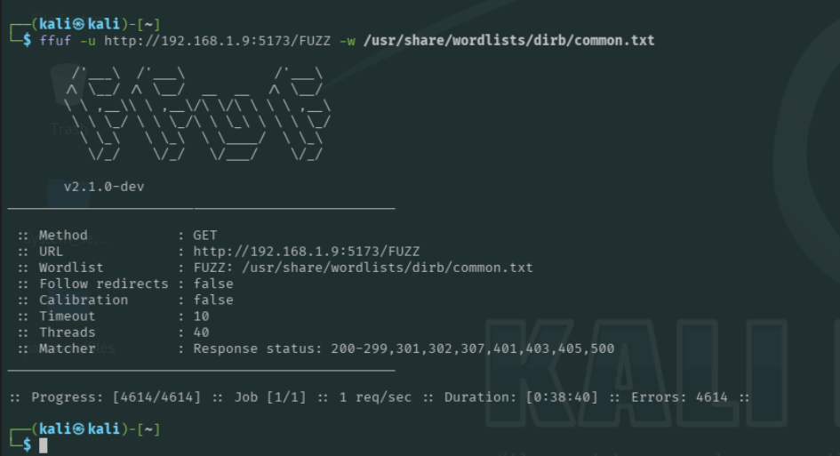
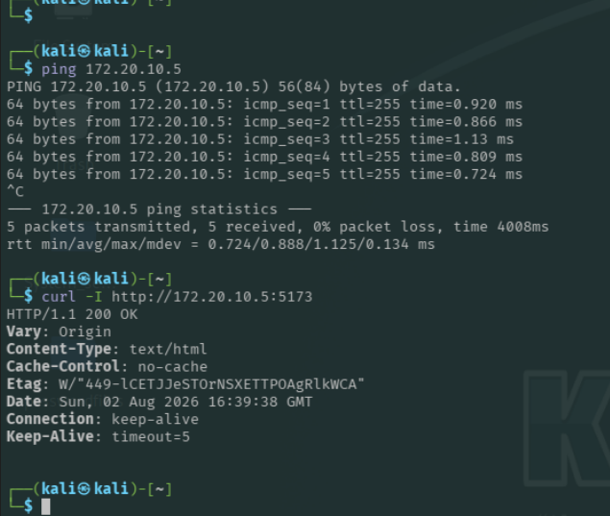
Network changed so we need to do it again
Directory Enumeration
Objective
To identify hidden directories and publicly accessible resources exposed by the web application.
Tool Used
- FFUF v2.1.0-dev
Command
ffuf -u http://172.20.10.5:5173/FUZZ -w /usr/share/wordlists/dirb/common.txt
Observation
The directory enumeration scan completed successfully. All tested paths returned identical HTTP 200 OK responses with the same response size (1097 bytes), word count (111 words), and line count (25 lines).
This behavior indicates that the application likely serves a common response (such as a single-page application entry point) for both valid and invalid routes. Consequently, the scan did not identify distinct directories or resources based solely on response status.
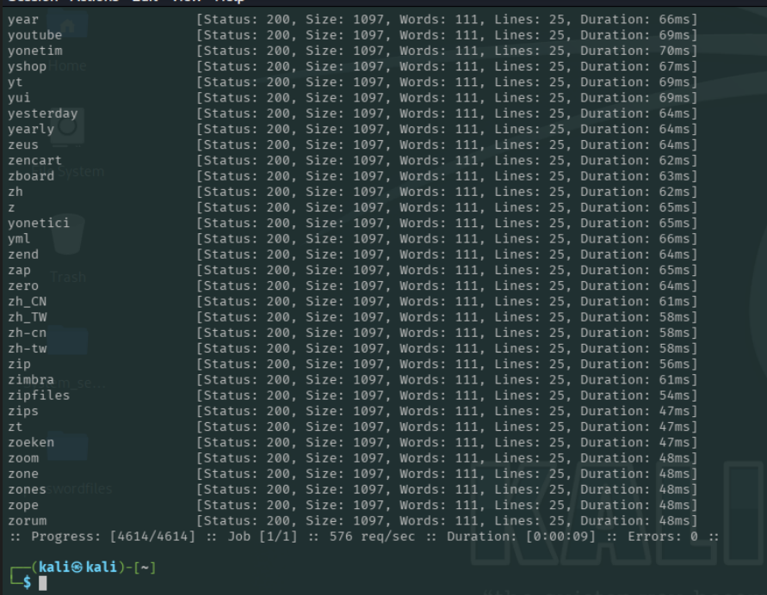
HTTP Traffic Analysis
Objective
Capture and analyze HTTP requests generated by the application during normal browsing.
Tool Used
Burp Suite Professional
Initial Requests Observed
Method | Endpoint | Purpose
GET | / | Home page
GET | /@vite/client | Vite development client
GET | /src/main.jsx | React application entry point
GET | /@react-refresh | React Fast Refresh
Observation
The captured traffic indicates that the application is running in a React development environment powered by the Vite development server.
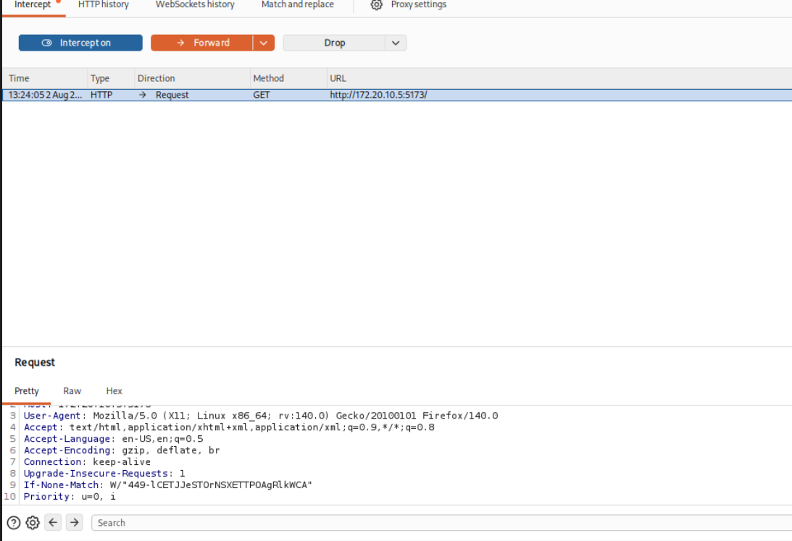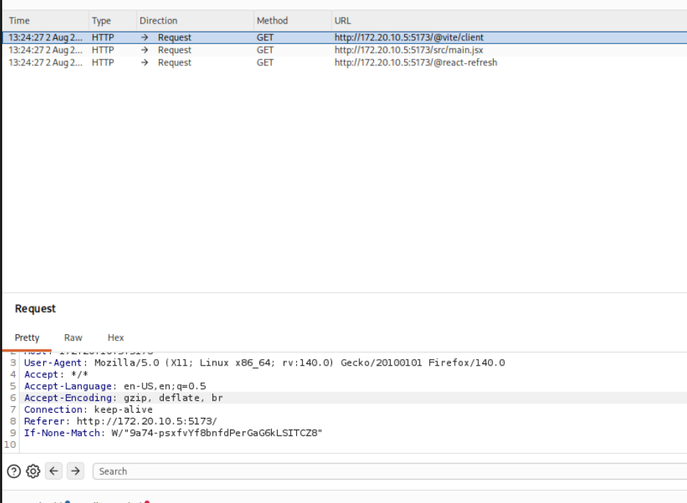
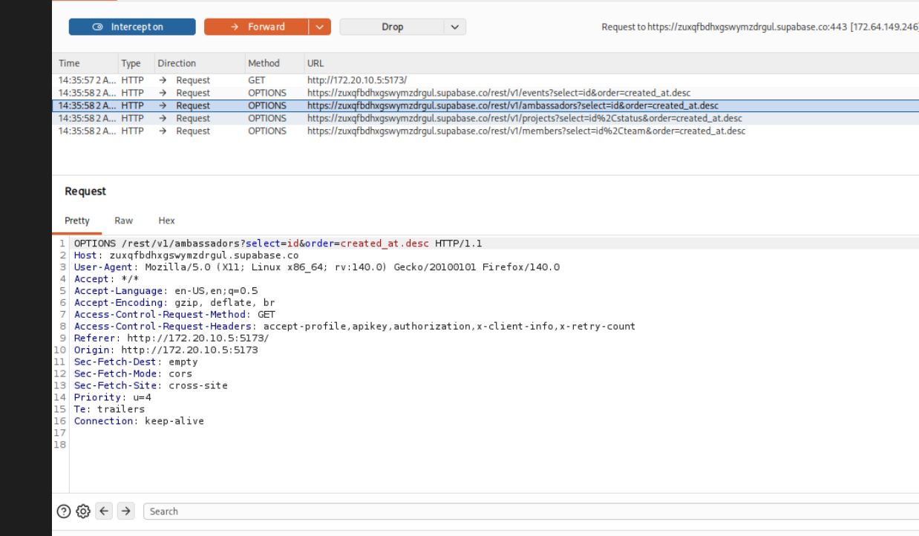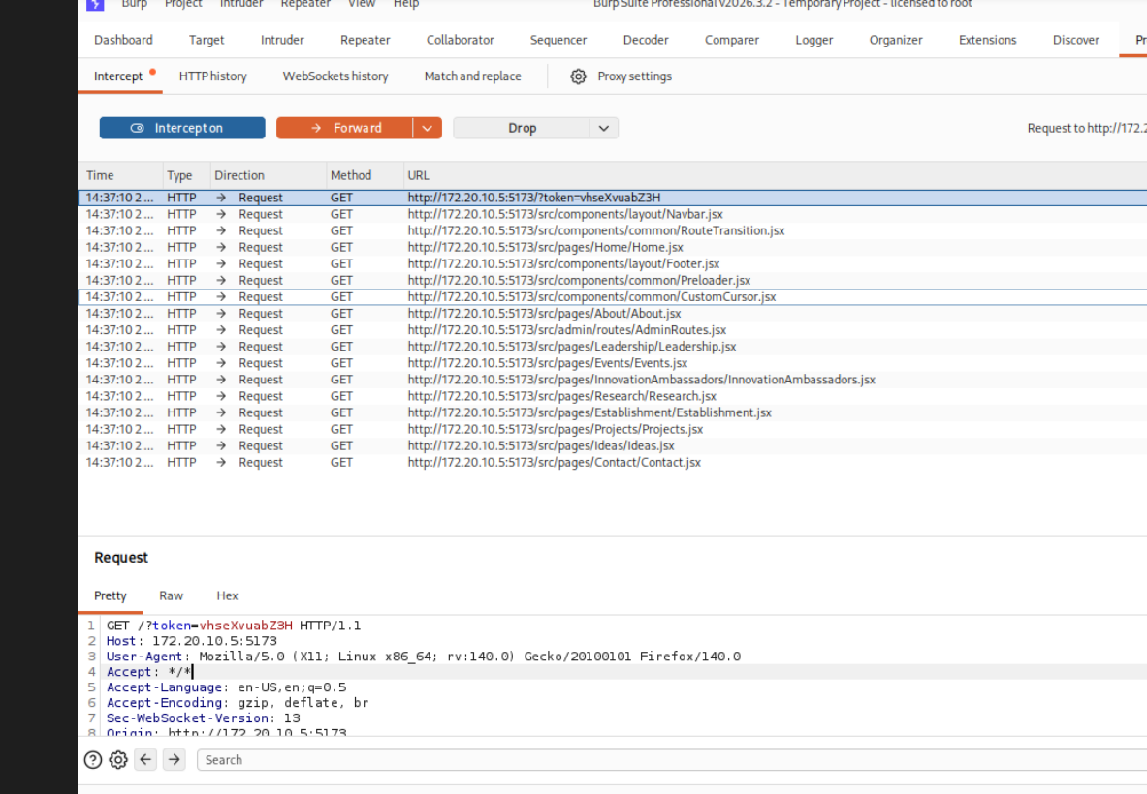

Security Verification
Supabase API Key Enforcement Verification
Severity -Informational / Passed Security Check
OWASP Category
A01:2021 – Broken Access Control (Verification)
Description - The application uses the Supabase REST API to retrieve public event data. Manual testing was performed by removing authentication-related headers from API requests to verify whether the backend enforces access controls.
Test Cases
Test | Result
Removed Authorization header | 200 OK (public events remained accessible)
Removed Apikey header | 401 Unauthorized
Removed both Authorization and Apikey | 401 Unauthorized
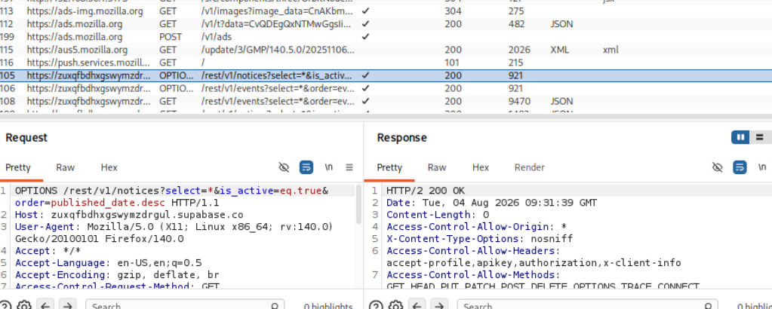

After sending the the supabase base response to repeater
Test 1 — Remove Authorization
And this one was the response that I got
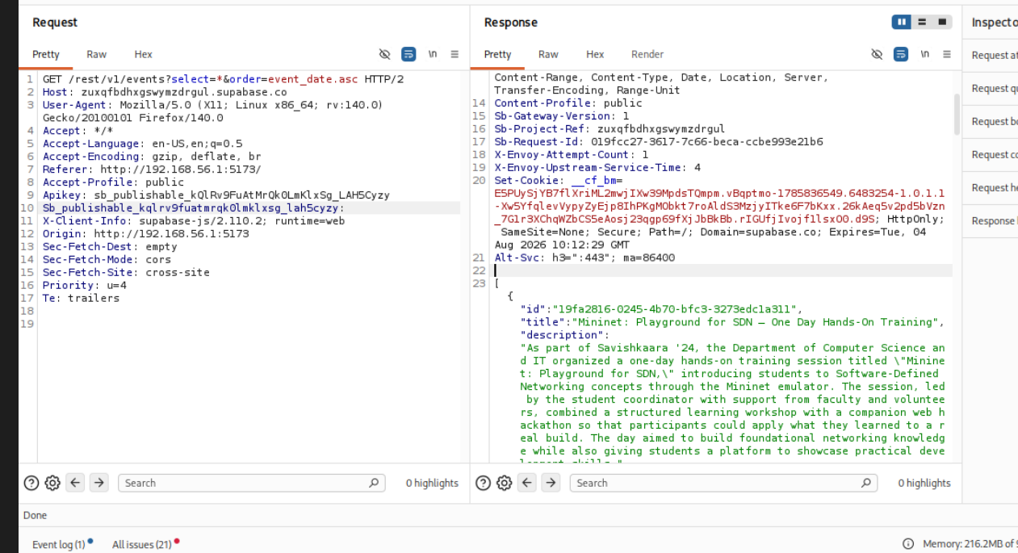
Removed Authorization header
Result:
- Removed: Authorization
- Kept: Apikey
- Response: HTTP 200 OK
- Data returned: All events
Is this a vulnerability?
Not necessarily.
With Supabase, this is expected if the events table is intentionally public.
The key point is that the remaining Apikey is a publishable (public) key, not a secret key. Public event listings are often designed to be readable without user authentication.

Test 2 — Remove Apikey
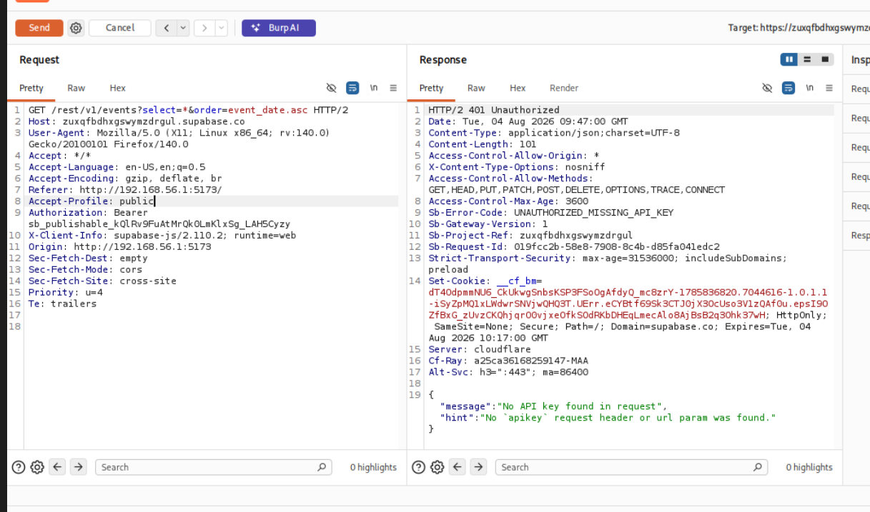
Assessment
This means:
- The backend requires a valid API key.
- Requests without the API key are rejected.
- This is not a vulnerability.
Remove BOTH headers
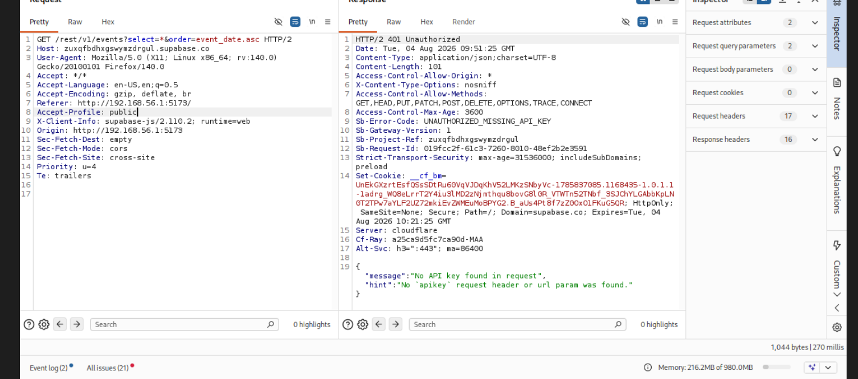
shows the API is enforcing the requirement for a valid publishable key.
Conclusion: There is no vulnerability here. This is behaving as expected.

